# Facebook Live Streaming

Test link: http://13.92.133.113/facebook.aspx

Steps to do the live streaming.

1. Prerequisites.
   1. Download the OBS studio(This is a streaming software) from the below link and install.

<https://obsproject.com/download>.

1. Use the http://13.92.133.113/facebook.aspx to generate the Stream URL. Steps below
2. Click on the Facebook login button
3. It will ask for the username and password (use [everywhere.e@yahoo.com](mailto:everywhere.e@yahoo.com) and Test@123 as username and password.
4. Once you authenticate with the facebook, click on the GenerateStreamURL link.
5. This will generate a stream URL something like the below one.

<rtmp://rtmp-api.facebook.com:80/rtmp/126944321119865?ds=1&s_l=1&a=AaYaDr3jSw_EWhJs>

1. Now open the OBS studio and click on setting, it will open the below window.

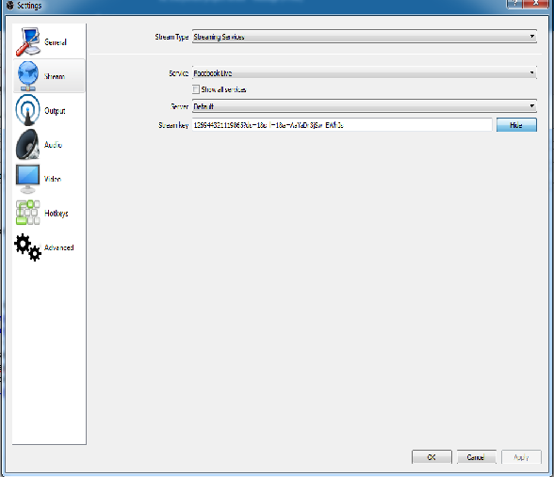

1. Please note there is a field called Stream key, copy and paste the above generated stream key(126944321119865?ds=1&s_l=1&a=AaYaDr3jSw_EWhJs) into the textbox above and click Apply and OK.
2. Now from the main window select the Source as “Window Capture ” and click on start streaming.
3. The activities done on desktop/laptop window will be live streamed on the Facebook account.

